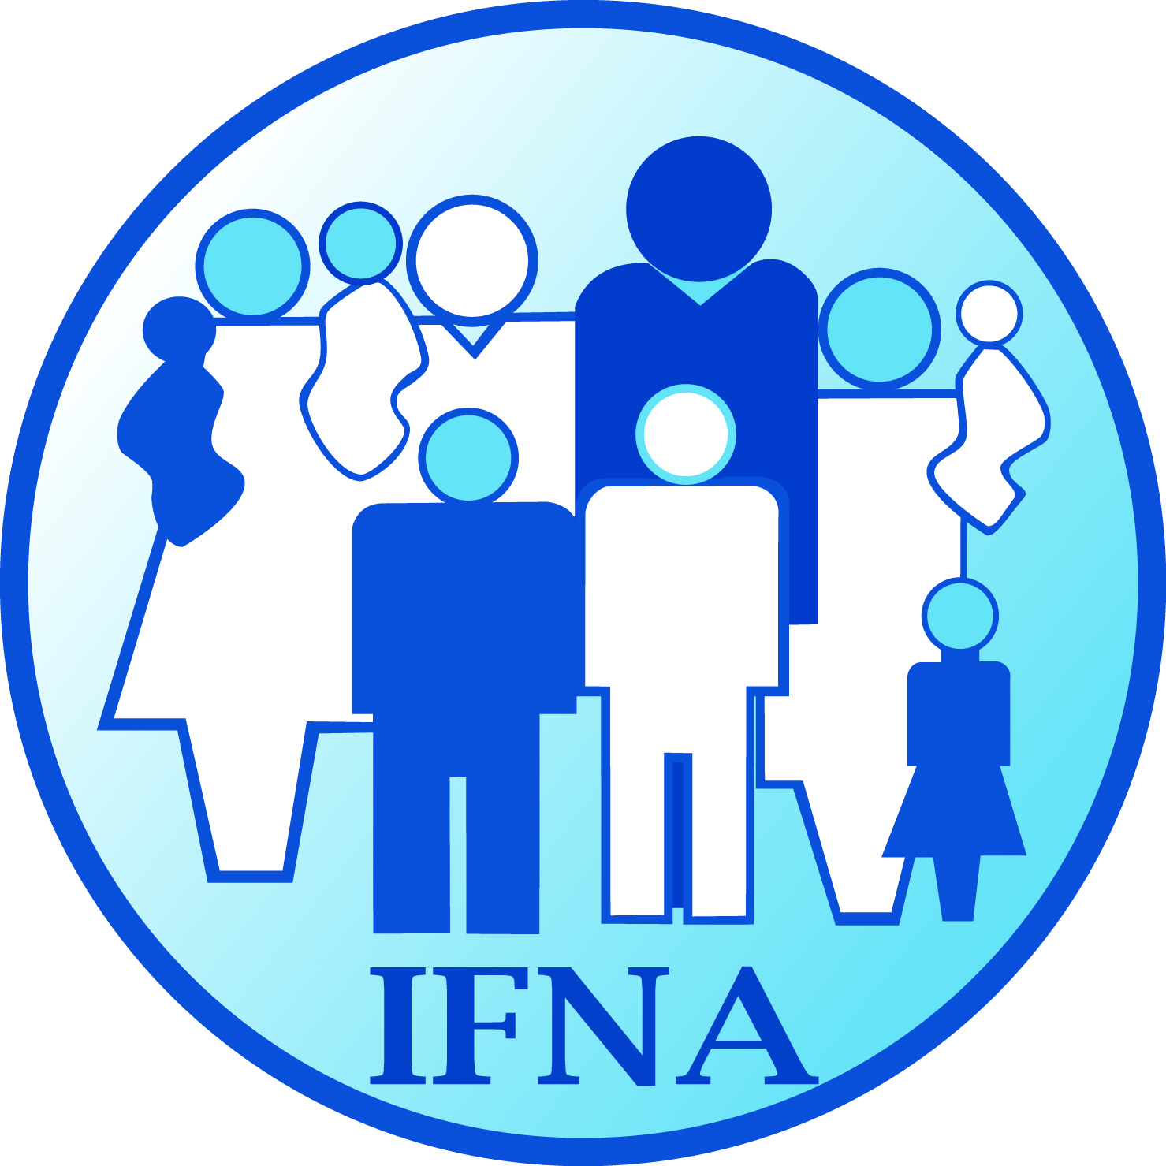

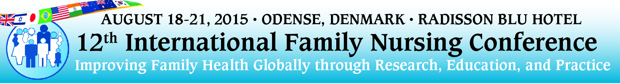

Support the IFNA 2015 Conference
An Invitation to Become a Country Liaison

To enhance the worldwide participation of nurses for the 12th International Family Nursing Conference, the official meeting of the International Family Nursing Association, August 18th to 21st 2015, the Conference Planning Committee invites your participation as a country liaison. The role of liaison is to disseminate information, promote involvement, and encourage attendance in their own country. Country liaisons must be IFNA members and will work closely with the Planning Committee to identify key audiences and develop strategies for promoting the conference in their country. We hope to have multiple liaisons from many countries.

If you are interested in becoming a Country Liaison or have questions about the role, please contact either:
Regina Szylit - szylit@usp.br or
Veronica Swallow - veronica.swallow@manchester.ac.uk
Jane Lassetter – jane_lassetter@byu.edu

We look forward to working with you to plan IFNA’s next meeting!

Please provide the following information: (please print clearly)

Country: ______________________
Name: ______________________________________
Email: _________________________________
Alternate Email: ___________________________
[ ] I would be interested in being the primary contact for my Country.

Conference Co-Chairs

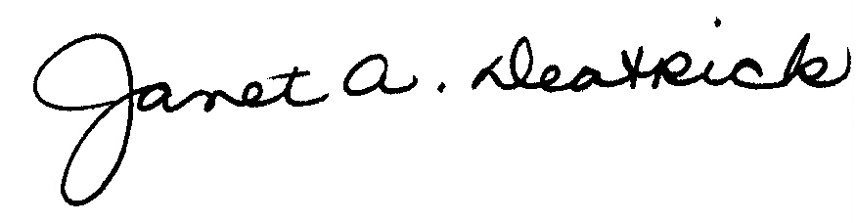 | 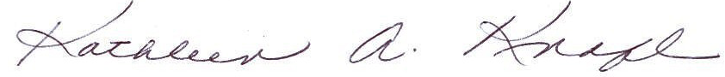
Janet Deatrick | Kathleen Knafl

